**Assignment Day 15 and 16 | 16th December 2020**

Question 2: Working with Elastic container service using fargate

Step1:Getting started with amazon ECS using fargate

SS1:ECS console

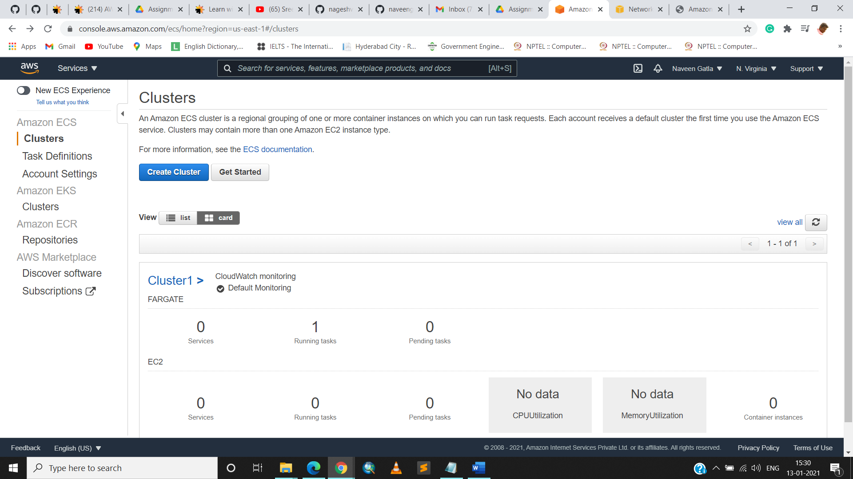

Step2:Creating container and task definition

SS2:2nd panel with all options visible

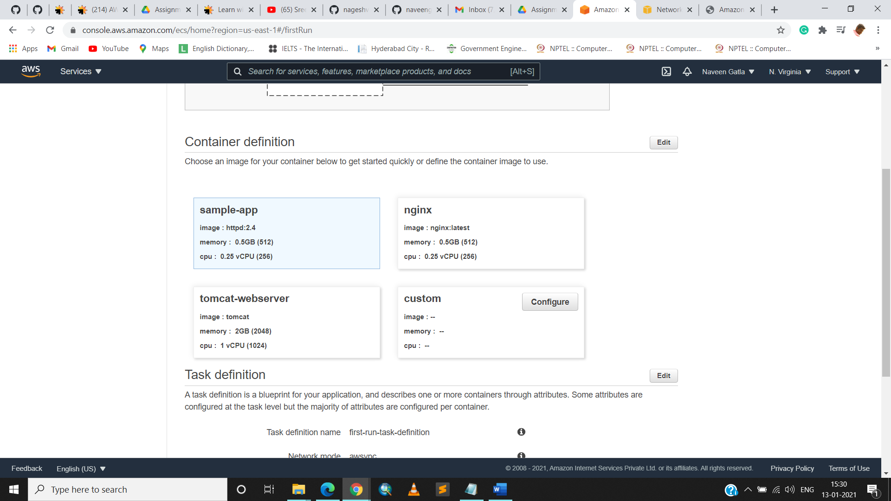

Step3:Configuring the service

ss3:next panel

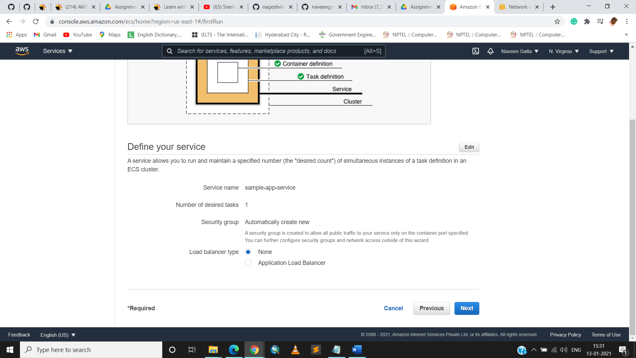

Step4:Configuring the cluster

ss4:next panel

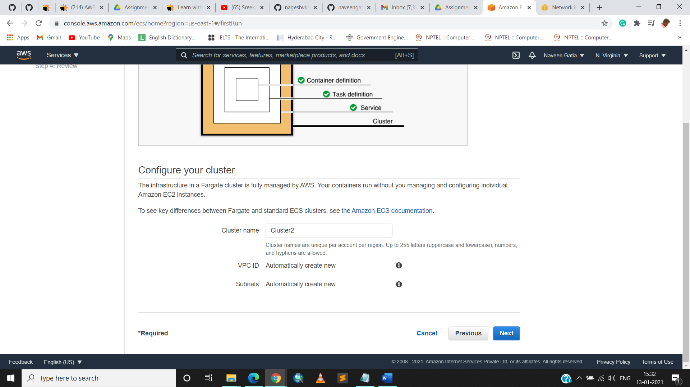

Step5:viewing the service

ss5:Dashboard displaying the cluster created

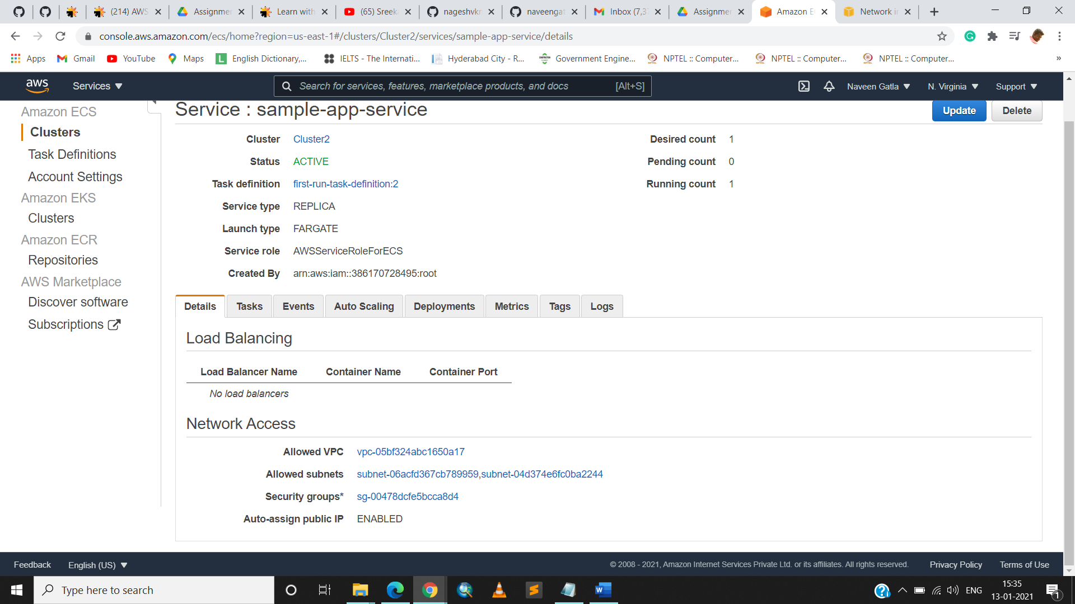

ss6:cluster information

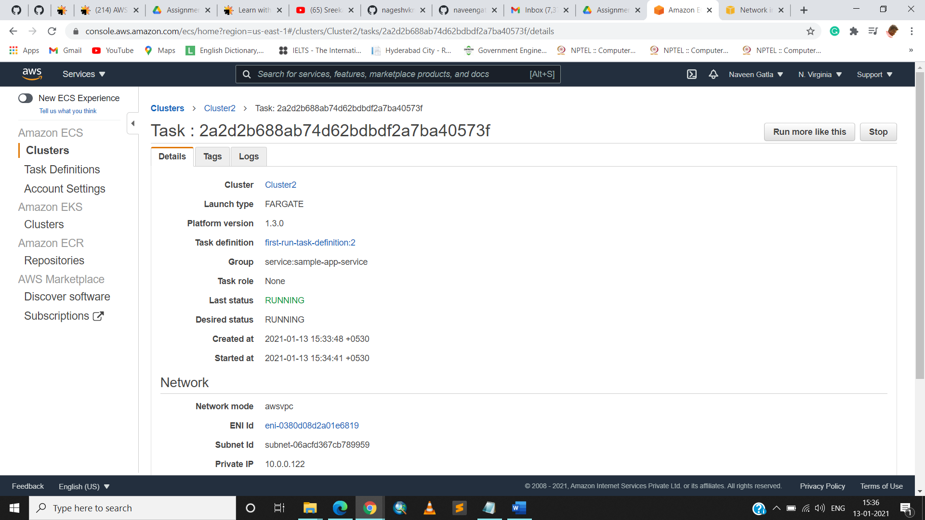

ss7:panel displaying ENI ID

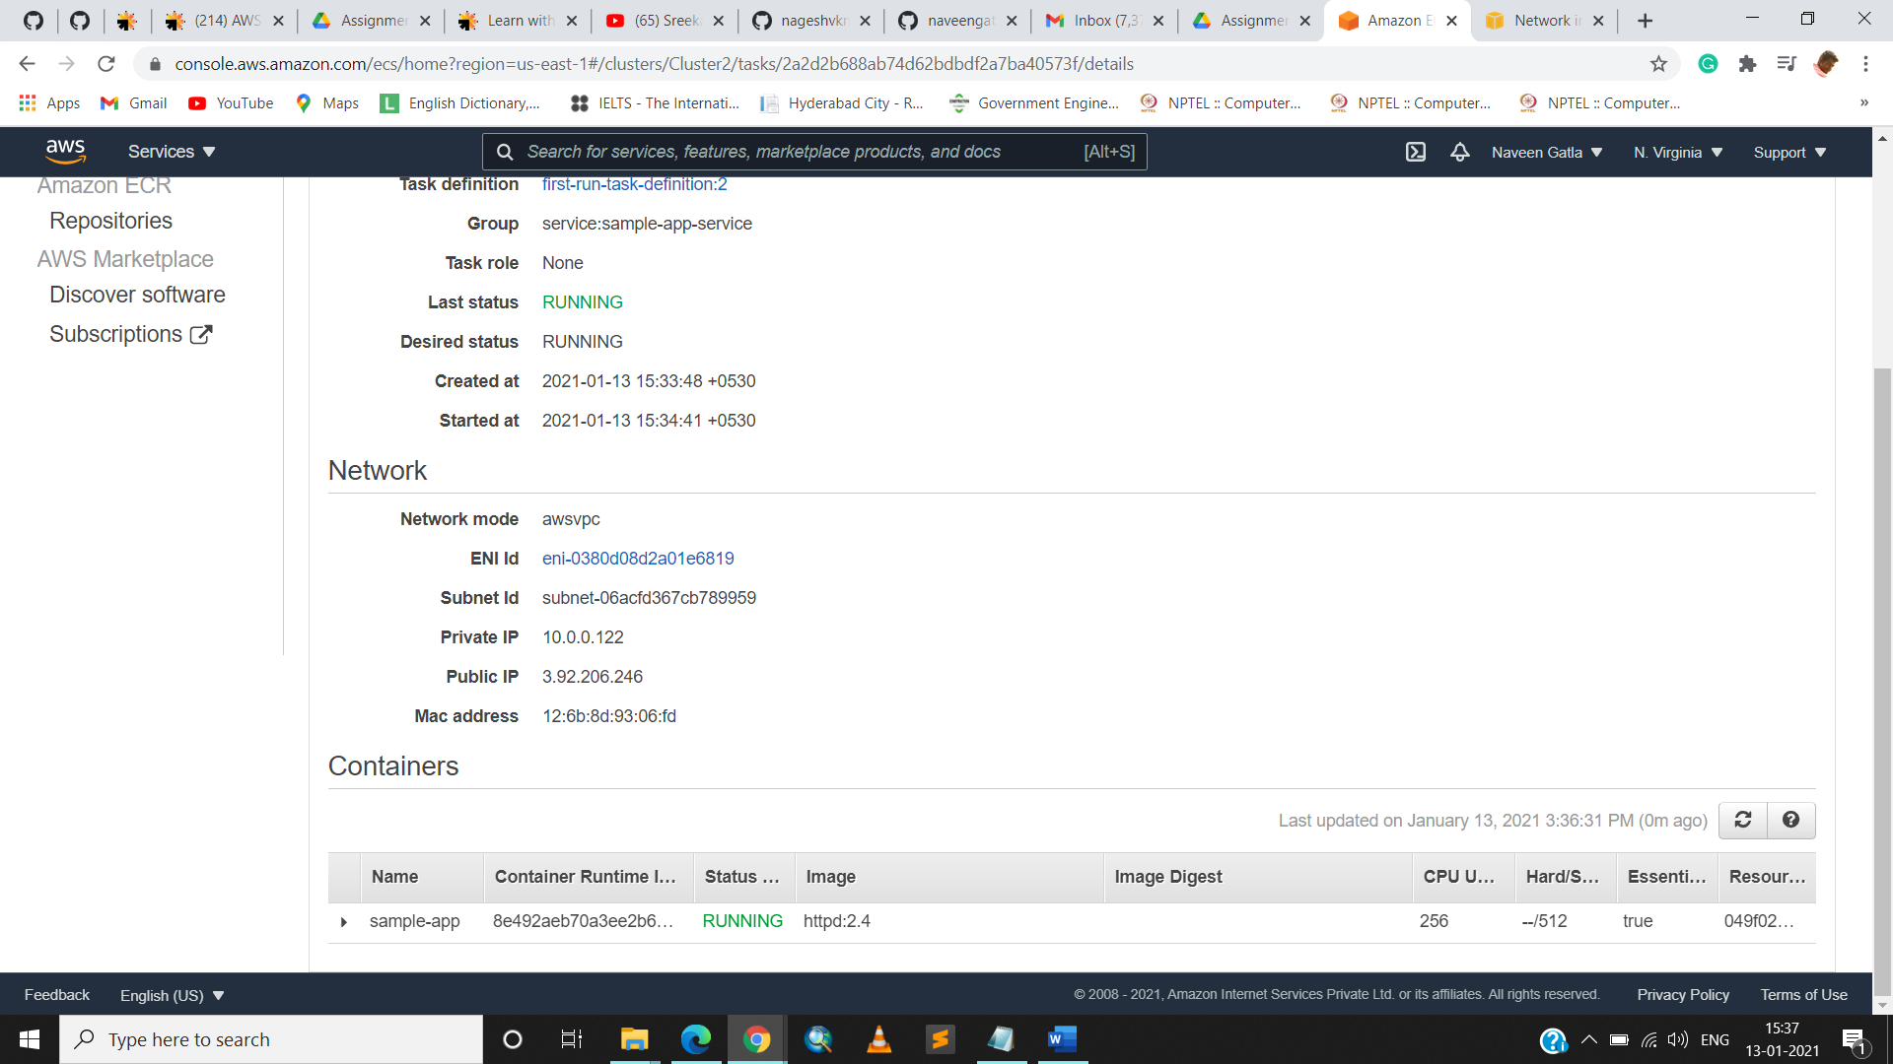

ss8:Panel displaying the private, public, and the macid

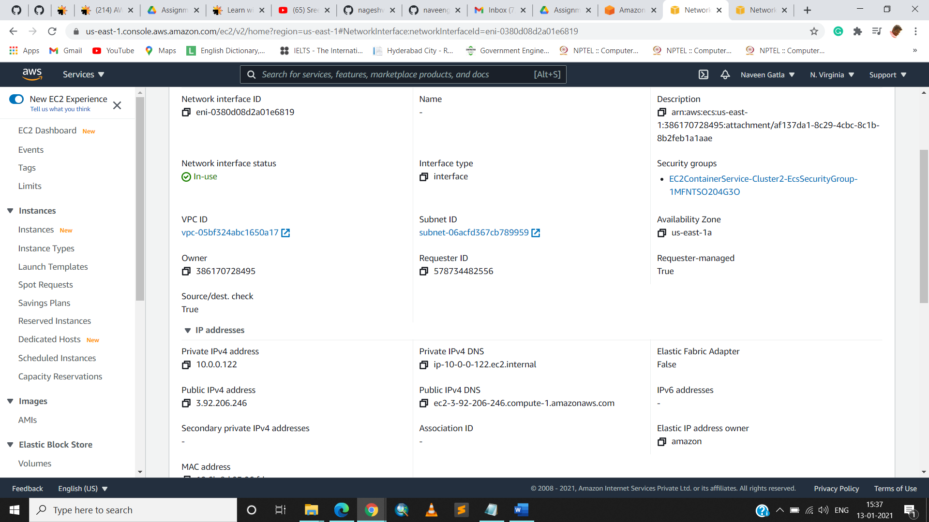

ss9:display application

